Zoom And Go
Software Usage and Reference Manual
March, 2021
V. 2.0

CONFIDENTIAL
FOR ZOOMANDGO CLIENT USE ONLY

Table of Contents
Introduction 1
Launching ZoomAndGo 2
Quick Start 3
The Zoomer Novice 8
Hotel Search 9
Booking a Room 12
Becoming a Confident Zoomer 14
Map Navigation 15
Location Search Field 16
Client Code 18
Rate Code 19
Visual PNR 20
Map and Navigation Controls 21
Hotel Icons 22
Hotel List View 23
Sort, View and Highlighting 24
Special Offers, Extra Hotel Amenities 25
Per Diem Rates 26
Sorting Hotels 27
Filtering Hotels in List 28
Additional Info on Hotels (Address, Phone, Street View) 30
Hotel Room Rates Page 31
Room Rate Details 32
Room Rates Summary by Rate Type 33
Filter Controls for Room Rates 34
Special Offer Details 35
Hide Non-Refundable Rates 36
Filtering Room Rates by Keyword 37

Introduction
This manual describes how to use the Zoom And Go software that will save you more than an hour every day in finding the relevant hotels for your clients than by using the GDS alone.
Zoom And Go is a map-based hotel shopping and booking platform that is fully integrated within an agent’s workflow in the GDS.

In essence, we are giving you the keys to a Ferrari but we need to teach you how to start the car and drive it to the corner store first. That’s what the first two sections of this manual are about. By the time you are through “The Zoomer Novice” and “Becoming a Confident Zoomer”.

Launching ZoomAndGo
After you sign in to Sabre 360, in order to ensure that ZoomAndGo connects to your session in Sabre you will need to sign in again as shown below when the black screen / emulator appears
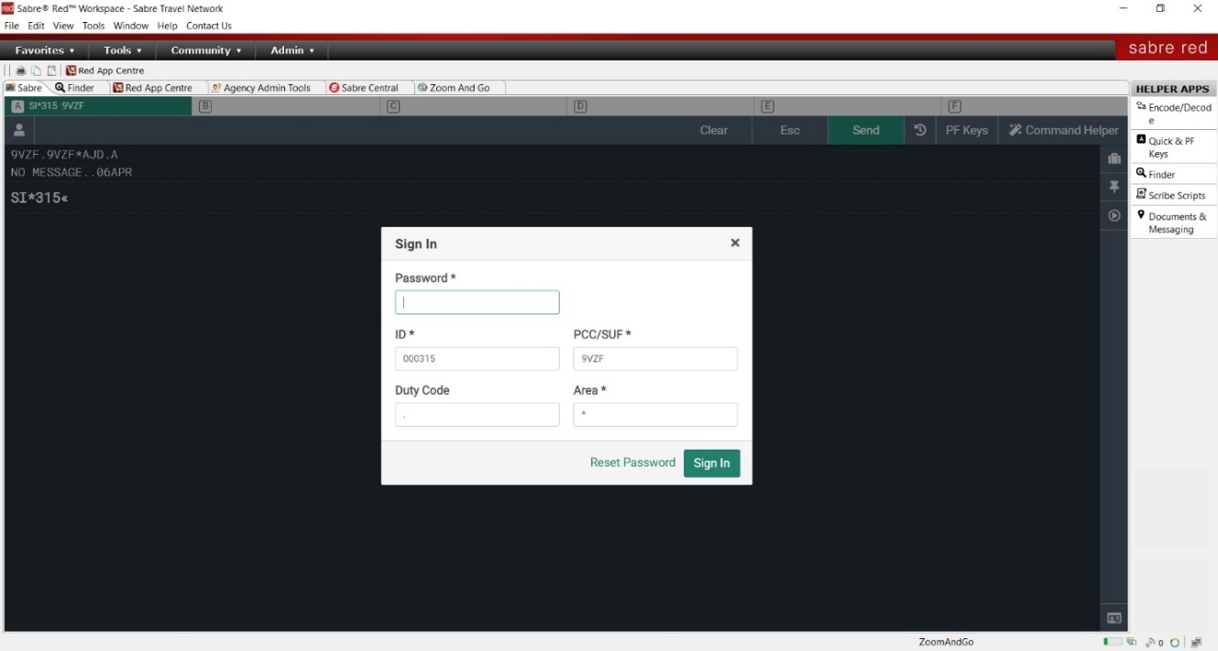

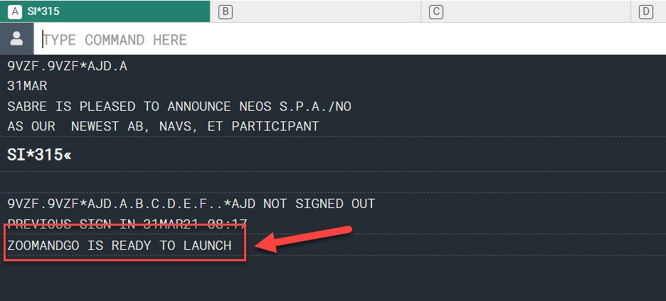
You will know that Sabre has connected to Zoom And Go as soon as the message “ZOOMANDGO IS READY TO LAUNCH” appears on the screen as shown below (usually less than 5 seconds).

In order to launch Zoom And Go, the above message must appear first.
If you have left your computer idle, Sabre will timeout and you will have to sign in again. After you do so, however, you might get the following message on your screen after trying to launch Zoom And Go again in this instance. In the example below, an agent was trying to launch the map to the BOS airport and gets a message that the map could not launch. If this happens, just enter “SO” to Sign out and then Sign in again to restart the connection to Zoom And Go.

Once again, you may need to wait 5-7 seconds for the message ZOOMANDGO IS READY TO LAUNCH to appear. As described above, this message must be present to launch the map so if it doesn’t happen after a short wait, either:
1. Do a quick normal search within Sabre (i.e HOTMIA) to help jumpstart the connection to ZoomAndGo again
2. Enter SO and then SI to Sign out and Sign in again.
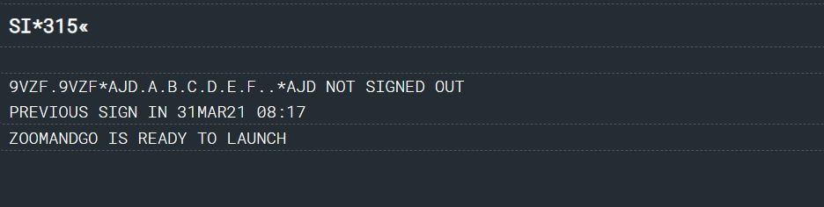

Quick Start
To get your feet wet quickly, we are going to launch the map and search for a hotel. You can launch ZoomAndGo from Sabre to search / book a hotel with after booking your air segment or without having air booked.
Let’s start with a quick example to show how easy it is to search for a hotel. You can search for a hotel using either of the following commands that you are used to doing in Sabre:
HOT
HOD
We are going to use “HOT” to get you started.
At the moment in the GDS, you would enter the IATA code after the HOT. In ZoomAndGo, we want you to become an Instant Destination Expert so we are going to marry the power of Google searching into the GDS and allow you to find hotels that are exactly where your client is or needs to be. Think of everything you enter after the HOT entry as a type of Google search where you can enter ANY destination in the world.
For instance, this means that you can now enter any of the following into Sabre after the HOT command and find availability for any hotel in the area sorted by distance to the location your client wants:
- Street Address (1600 Pennsylvania Ave)
- Street Intersection (Berkeley and Beacon St)
- Neighbourhood / Part of Town (Upper East Side, Soho, NYC)
- ZIP / Postal Code (90210)
- Attraction / Point of Interest (Eiffel Tower, Faneuil Hall)
- Army Military Bases (Fort Campbell)
- Airport Code
In order to launch the map and view hotels, simply type in **MAP after any of the above potential destinations.
So, until now, you could only enter in the IATA code of the nearest airport to where your client needed to be, now you can enter where they need to go after the HOT and launch the map using **MAP. At that point, a new window will open taking you to the destination you have selected centered on a map with all the hotels on it.

HOTLGA
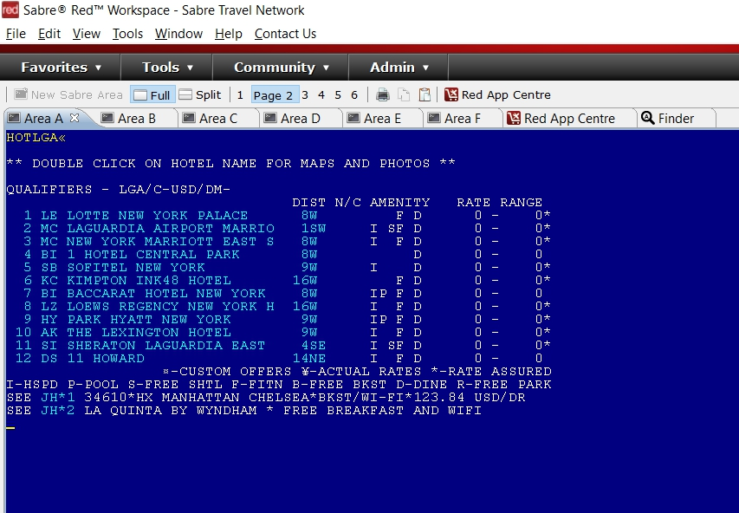

Sabre - Old way - Based on Airport IATA or exact match to ZIP code or address

HOTWhere does your client need to be?**MAP
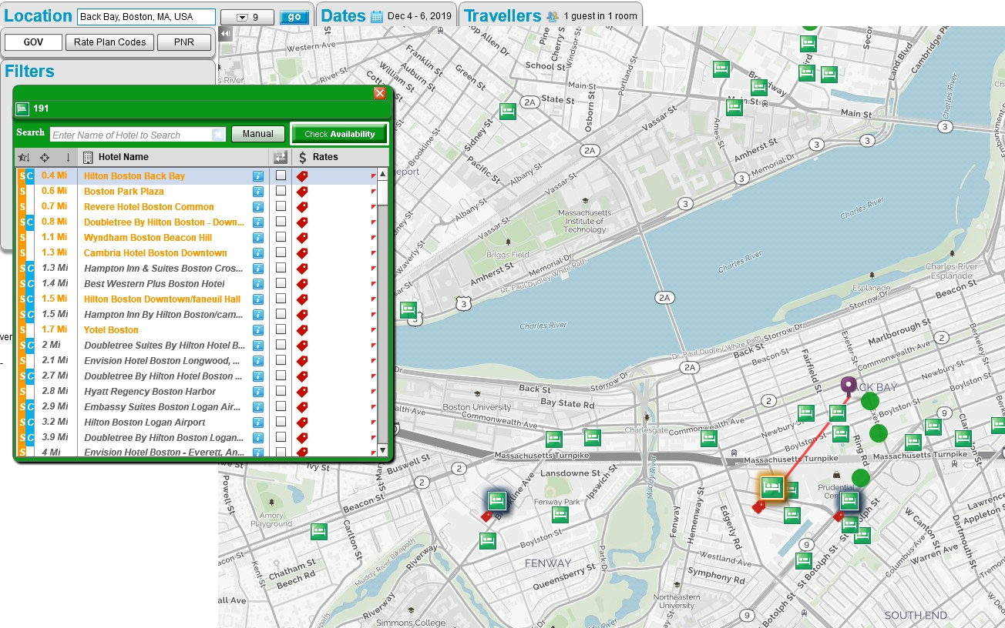

ZoomAndGo – ANY destination

HOTBack Bay, Boston**MAP
TIP: If the window for the map does not open on top of Sabre, simply click on the system tray at the bottom of your screen in Windows to open ZoomAndGo.
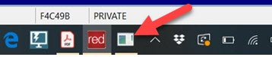

Here are some examples of potential searches using ZoomAndGo. Try it now yourself and see what happens for any destination.
Potential Destinations | Sabre Entry | Corresponding ZoomAndGo Map Display
Street Address |  | 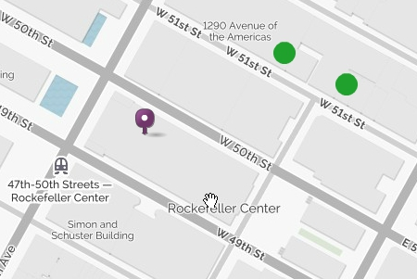
Street Intersection |  | 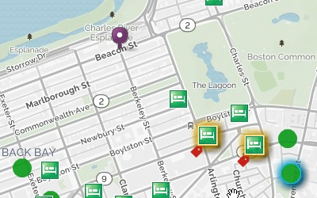
Neighborhood, subway station, part of town |  | 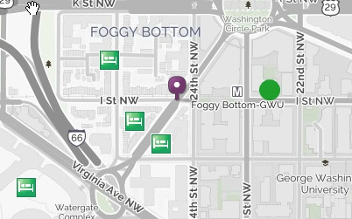
ZIP / Postal Code |  | 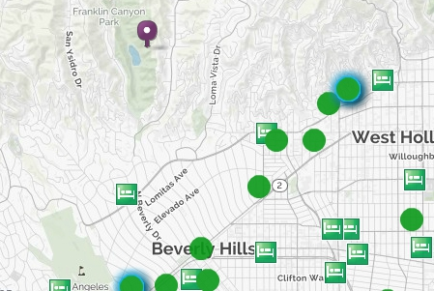
Attraction / Point of Interest |  | 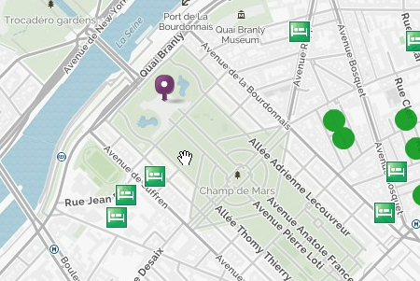
Army Military Bases |  | 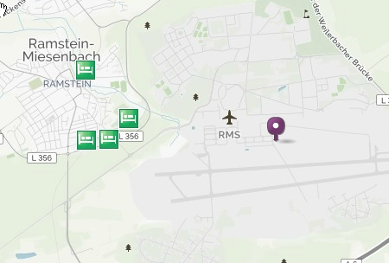

Tutorials – Moving from Novice to Ninja
At this point, you should get the idea that you can insert anything after the HOT command in Sabre and then append the destination with **MAP to launch from Sabre to go there. As you saw, a map will launch with all the hotels in proximity to the destination you entered (not just a limited list of hotels whose address is an exact match to what you are looking for as in the GDS right now).
What we will do next is take you through a hotel search at the Novice Level and then when we get to the next level of training, we will take you through a more complicated example and show you how quickly you can find the answer for your client.

The Zoomer Novice

Client Request
- Your client is travelling to Orlando, Florida for a meeting at the Orlando Regional Medical Center - she doesn’t know the address
- You have already booked the Air
- She would like to stay for 2 nights – Dec 11 and departing on Dec 13.
- She must stay at a hotel less than the Gov’t per diems for this destination
- You need to book a hotel that is closest to the above location that the best DoD Preferred Rate, CWTSato Preferred Rate or Fedrooms Rate, in that order.

Hotel Search

Enter the following into Sabre:

The map will open as shown below with the location of the Orlando Regional Medical Center shown by the purple pin and all the hotels sorted by Agency preferred hotels and then by distance. In order to bring up all the hotels that are relevant to your client, enter their Client Code into the box indicated by “1” below.

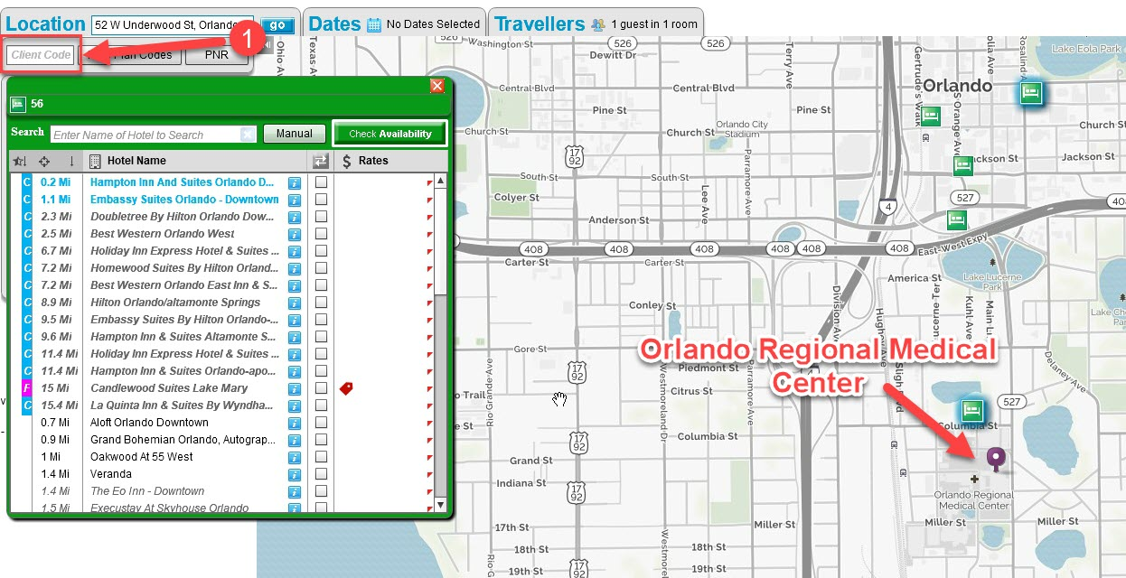

In this case, enter in “GOV” into the box as shown below and select “Military & Government”. The loading of all the hotels around the world could take between 20-25 seconds but after the first time you perform this load, it will be significantly less for any other destination.

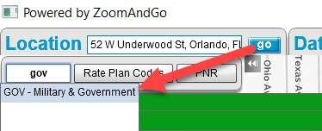
The hotel list will now show the intersection set between all the government preferred hotels listed in order of preference and the CWT preferred chains along with any hotels that could provide commission for booking them as shown below:
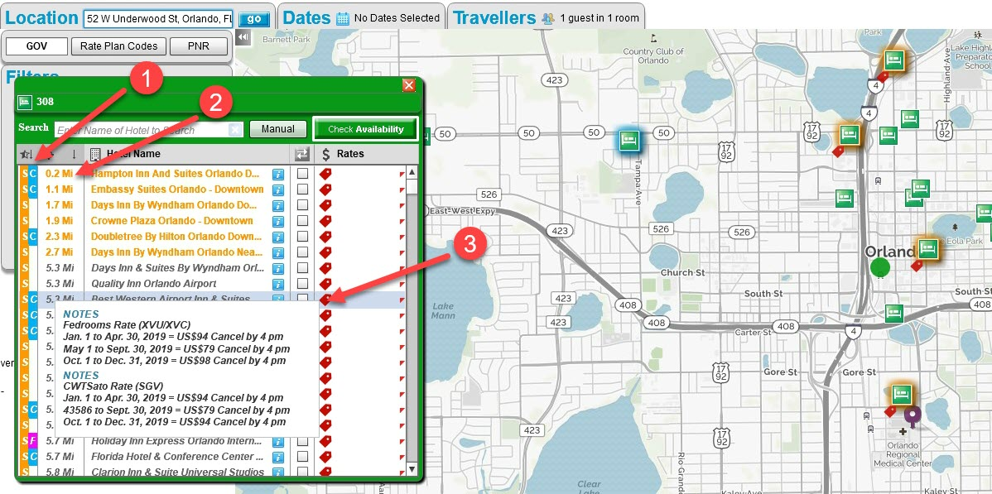
The first column on the left above (#1) shows the sort order from the government preferred hotel Rates (the left-most column) in the following order:
“D” = DoD Preferred Rates (Pink) – not present in the above example image
“S” = CWTSato Rates (Orange) – as shown in the picture above
“F” = Fedrooms (Blue) – not present in the above image

The second column on the left above shows the sort order from Carlson Wagonlit preferred hotel Rates as follows:
“C” = Carlson Wagonlit Chains (blue) – Shown above
“F” – Fedrooms (Pink) – These are hotels in which CWT can earn commission – there is one hotel visible in the example above.

The second column (#2) shows the distance from the location pin to the hotel shown.
The above hotel list is shown sorted first by Preferred Hotels and then by distance.
If you scroll over any of the red tags, you will see the following:
- Negotiated Rates by Rate Code and by date range (eg. XVL, SGV, XVU, XVC)
- Hotels that have Breakfast Included
- Hotels that pay Commission and how much
- Hotels that have LRA
In addition to the above, as soon as you select the button for “Check Availability” and select dates, the red tag rollover will also show the Per Diem Rates (#1) as shown below:
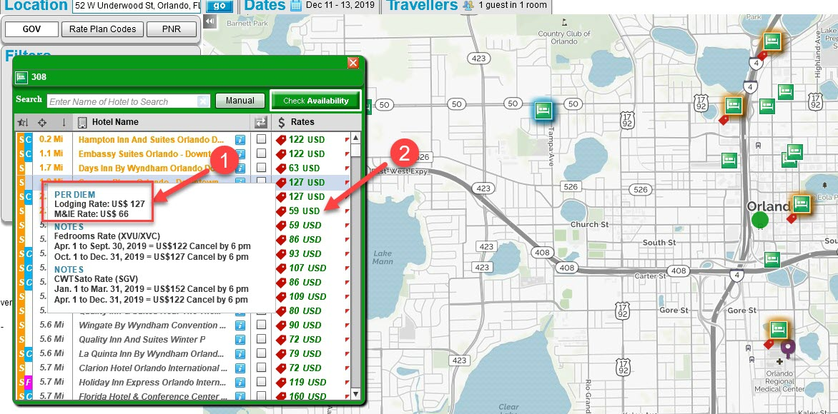
The rates shown in the column on the right (#2) are the lowest per night rate in the date range requested. This is the rate that you would get returned after performing an HOD request in Sabre (not at the initial HOT request).

Booking a Room

To view all the rates for a hotel, click on the hotel name area to open up the Room Rates Page:
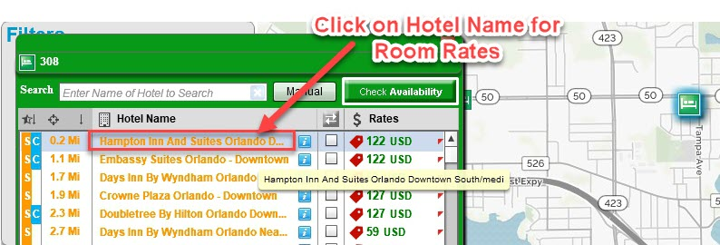

There is no need to select and input any rate codes as all the relevant rate codes have been pre-programmed to be returned for your agency.
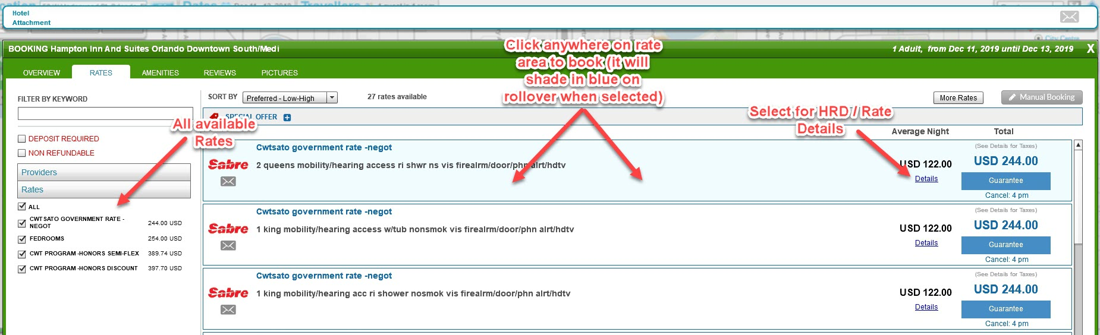

The room rates page will appear that will show all the rates available sorted in order of preference that has been set in the ZoomAndGo Admin as follows:
- DoD Preferred (XVL) Rates
- CWTSato (SGV) Rates
- Fedrooms (XVU/ XVC)
- CWT Corporate Rate
If any of these rates are not appearing in the Room Rates page it means that they are not available at the hotel.

The booking page will then appear on which you can enter the Client CC details, Frequent Flyer number and any Special Instructions (SI field). If you have a PNR loaded, this information will pre-populate if it is stored in the Remarks field. Note, that if the Credit Card has been masked for PCI reasons in Sabre that you might have to re-enter this information on this page.

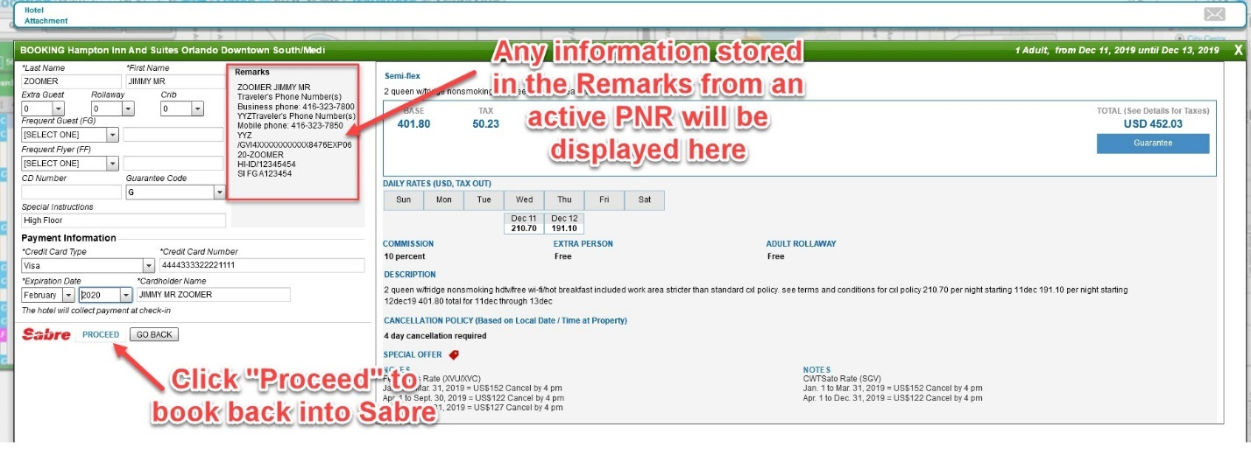

After click “Proceed”, the booking will be made into Sabre and will appear in the correct order and segment in Sabre as shown below.

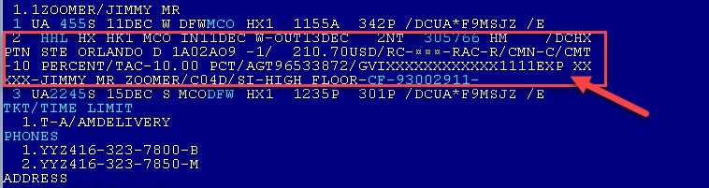

Congratulations! You just made you first booking in ZoomAndGo. We will now go through the above steps again and take a closer look at each page and what you can do.

Becoming a Confident Zoomer

As with anything, the more you use the software the more confident you will become so let’s take an in-depth look at each of the functionalities shown on the previous pages, starting with the map itself.

Map Navigation – with Legend
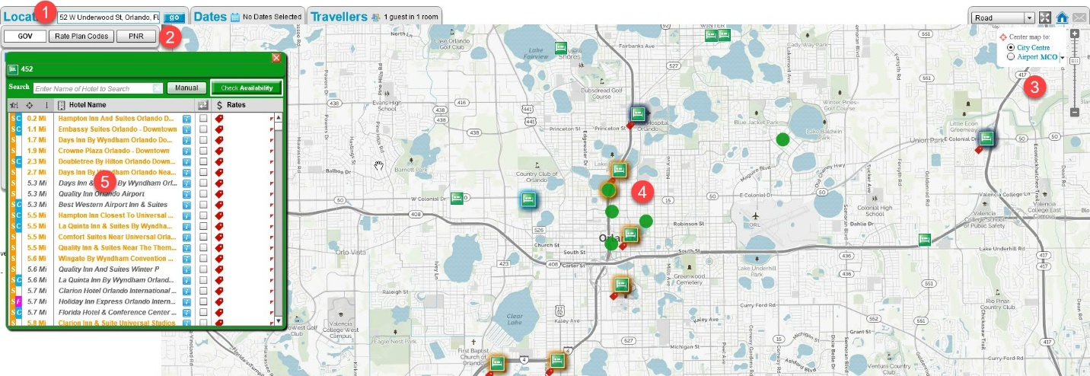

Location Search Field
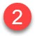
Client Code / Rate Codes / Visual PNR
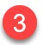
Map and Navigation Controls
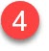
Hotel Icons
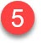
Hotel List View

Location Search
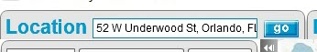

Located in the top left of the map display, this is where it all starts. Where does your client need to go? Think of this as a Google search for any destination in the world. When you launch from Sabre, this box will be populated by whatever you input after the HOT command as we saw at the very beginning of this manual.

You can enter any of the following into here for any destination in the world (and correspondingly any of the following after the HOT command in Sabre):
- Street Address
- Street Intersection
- Part of town / neighborhood
- ZIP/Postal Code (for any country)
- Subway / Underground / Metro stations
- IATA airport code
- Attractions / Points of Interest
- Army Bases / Convention Centers / Medical Facilities (Hospitals)
- City / Towns

You can enter a destination in ANY language and you can misspell it. If you don’t know the exact spelling of a place (How many S’s are there in “Bundestrasse” in Berlin?), just enter as much as you know and ZoomAndGo will bring back suggestions as follows:

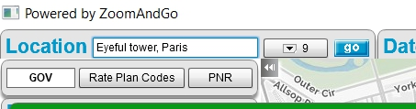

If you were to enter “Eyeful tower, Paris” because you really don’t know how to spell it, we will correct the spelling and take you there or bring back suggestions as shown below if the place it took you to was not correct:

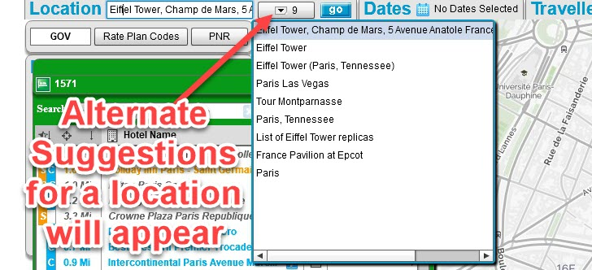

The only thing you can’t search for is a hotel name because this search box is about a / location. The hotels will appear on the map and you can filter to find the hotel you need in the hotel list view box below (#3).
TIP: To clear the entry field for the Location search, simply double click in the field to highlight the whole field and press delete. Also, just as would in Google, enter as much information as you would to make the search results more accurate. While ZoomAndGo will bring back the most popular results for the destination, you might find that entering in something like “White House” might not bring back the desired result but “White House, Washington” or “The White House, D.C.” will.

, Client Code / Rate Codes / Visual PNR

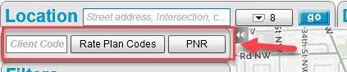

This area serves three different functions:

1. Client Code – This is where you would enter in a code associated to your client that would have been assigned in the ZoomAndGo Admin and it will bring up all the hotels for your client in the list view (#3) below sorted in order of preference.

For instance, for CWTSato Military and Government, you would enter in “GOV” and will bring up all the hotels in the list view sorted in order.

FROM THIS TO THIS
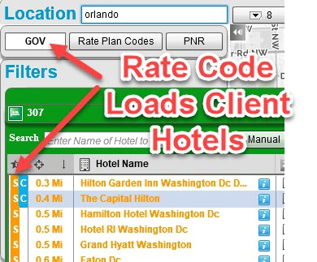
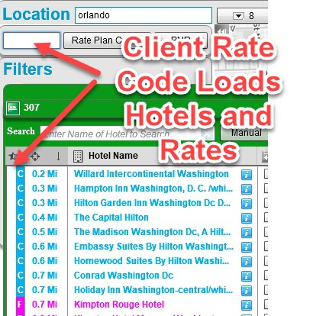

2. Rate Code – When you click on this middle button, all the rate codes that have been pre-loaded in the ZoomAndGo Admin for your client will display (see image below).

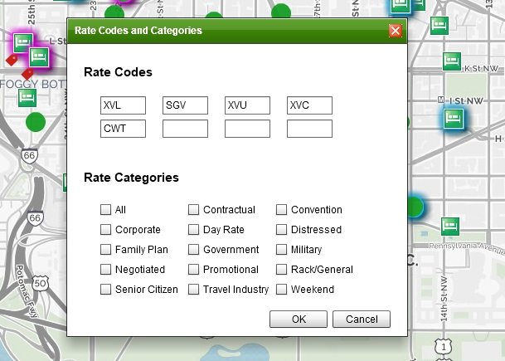

The order shown is the priority by which all the rates will be returned and displayed when a call for availability is made. If you wanted to add more rates to return, you can do so in the screen. For Sabre, you can add up to 8 Rate Codes

3. Visual PNR – When you click on this button, it will take you to a Visual representation of a PNR if you have one loaded into the Sabre workspace. If there is no PNR loaded it will look as follows:

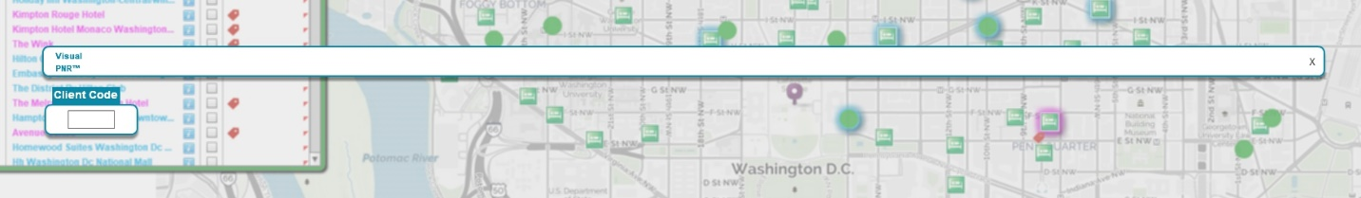

If there is a PNR loaded, this “Visual PNR” will show the air segments (red) and also the Hotel nights to be booked (grey) as shown below.

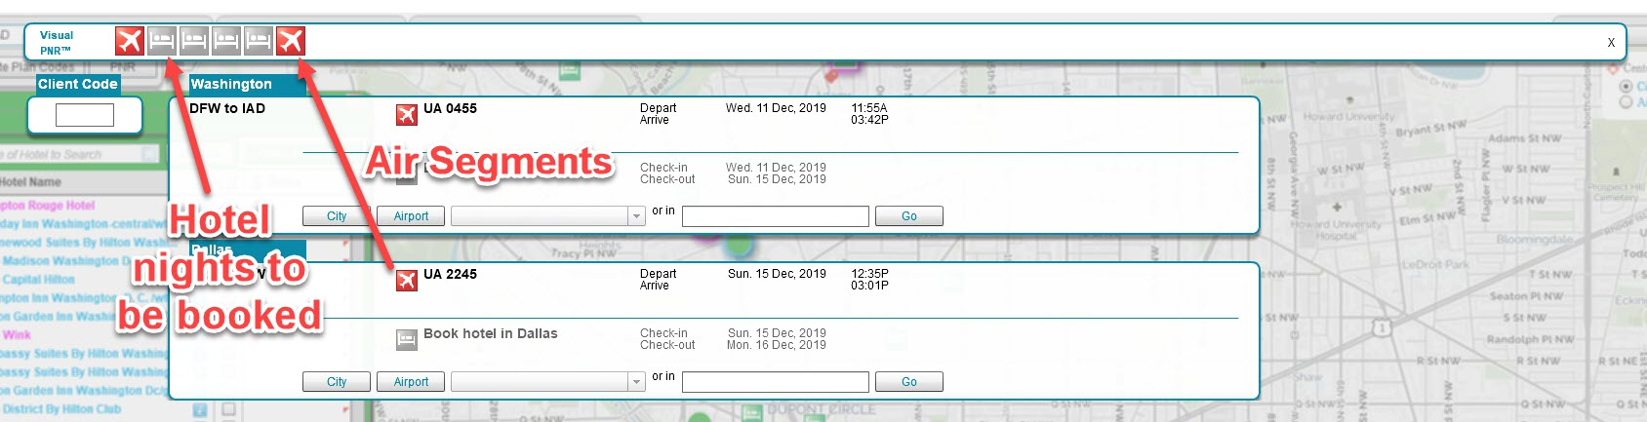

Map and Navigation Controls

Located in the top right of the map, you have controls for the following:
- Zoom in and out of map (Using Vertical bar showing “+” or “-“)
- Jump to closest IATA airport using the radio buttons
- Jump to closest main city associated to airport
- Switching map from Street / Road View to Satellite View
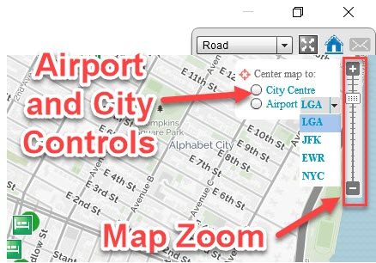

If you select the drop down next to the “Airport” it will indicate the closest airport to the area you are viewing. If you then click on the radio button, the map will go there.
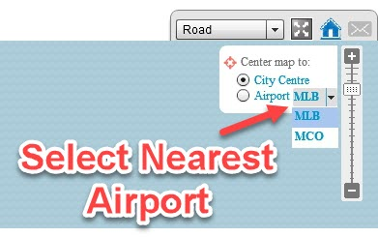

Hotel Icons

The hotel icons on the map appear in three different formats:
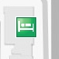
1. Green bed icon – Location of a non-Preferred / non-Client Negotiated hotel

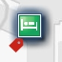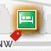
2. Green bed icon with shading – Location of an Agency Preferred / Client Negotiated Hotel

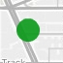
3. Green Circle – Concentration of more than one hotel. Given the elevation of the map we are looking at, there is more than hotel grouped together at this location. As you zoom in, these icons will split apart into multiple square icons (above).

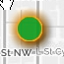
4. Green Circle with shading – Concentration of more than one hotel given the elevation of the map we are viewing. The shading indicates that this group has a one or more Agency Preferred hotels or Client Negotiated hotels inside it.
If you were to click on the green circle icons above, it will indicate the contents of the hotel in this location as shown below:
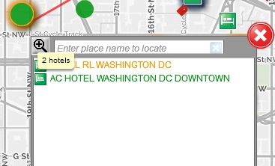

Hotel List View

This area is where all the sorting, filtering and Checking Availabilty for all the hotels occur. There is a lot of functionality with the power to find things quickly in this area.
Sort View and Highlighting – Agency Preferred Hotels Only
If there are no Client accounts and Negotiated hotels loaded in the Zoom And Go Admin but the Agency has Preferred hotels loaded, the List view would look as follows:
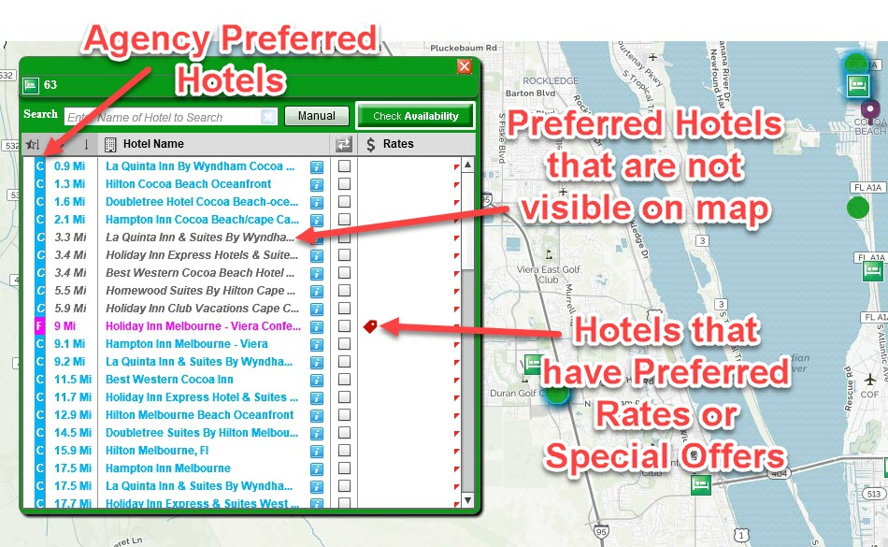
In the example above, all the blue shaded “C” hotels represent the Chains with whom CWT has Preferred relationships.
The “F” indicates the hotels for which there are Commissions available through Fedrooms. If you hover over the Red Tag in the rates column it will show the offers and the Rates as follows:
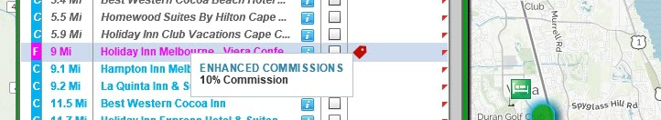

Sort View and Highlighting – Client Negotiated Hotels and Agency Preferred Hotels
When a Client code is entered into the “Client Code” box as described in #2 above or entered into Sabre as a DK code prior to launching ZoomAndGo (NOTE: the code is one that must be loaded into the ZoomAndGo Admin on initial configuration with the agency in order for this functionality to work), the Sort order will combine both the Client Preferred Hotels and the Agency ones as shown below:

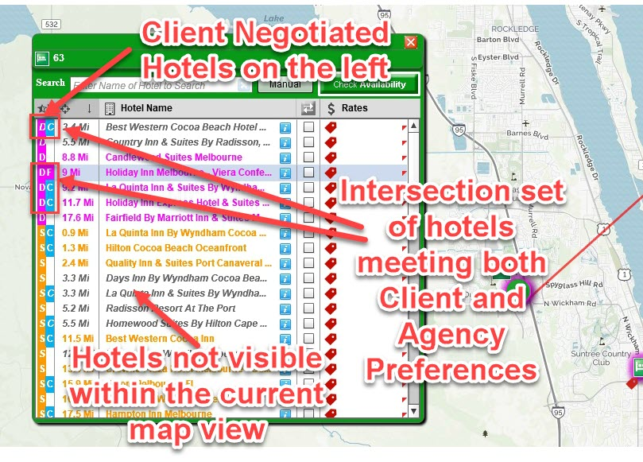

The objective in booking hotels once the Client hotels have been loaded is to find hotels that are the intersection set of both Client and Agency preferencing rules. This is indicated by having hotels shaded in both the Client and Agency sides of the Preference area (eg Shaded both as a pink “D” on the left side and as a blue “C” or pink “F” the right side or as an orange “S” on the left side and as blue “C” or pink “F” on the right side).

Special Offers, Extra Hotel Amenities

The appearance of a Red in the Rates Column indicates that the hotel is “in program” and has either rates for Client Negotiated Rate Codes (eg. XVL, SGV, XVU or XVC) or Agency Rate Codes (eg. ”CWT”). By rolling over this tag, it will reveal the Rates and the offers available – or if there is Free Breakfast, LRA or Commission payable and the amount of such as shown below.

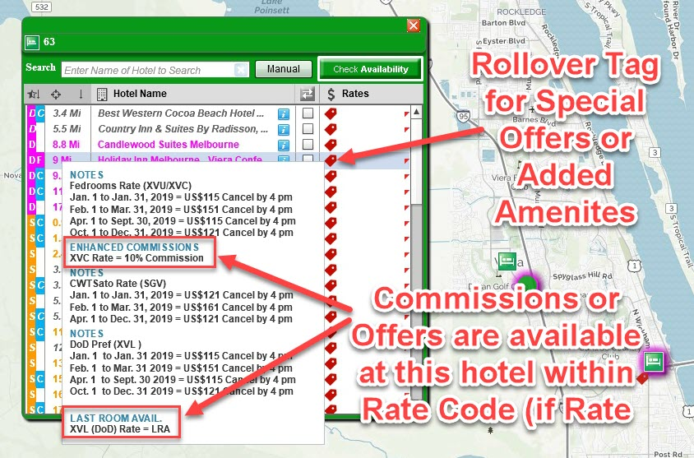

Per Diem Rates

To view the Per Diem rates for each hotel per the GSA web site, you must first Check Availability for the hotels. When the rates are returned, the Per Diems will appear when you rollover the red tag (as shown above).
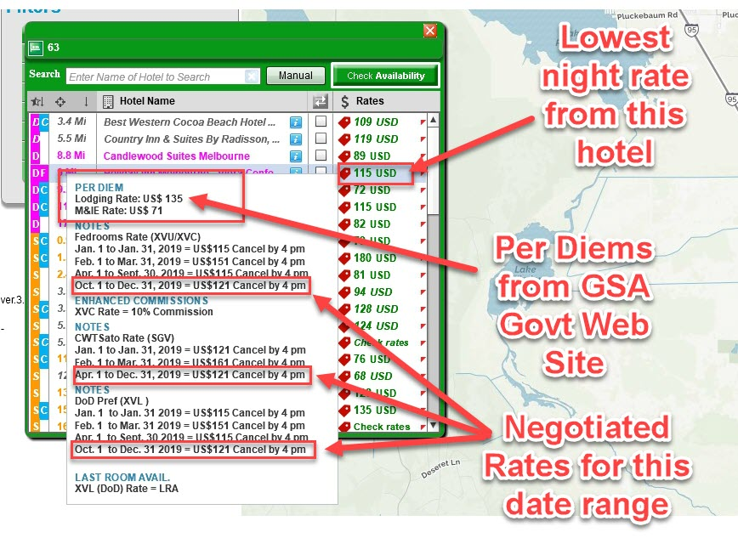
For the hotels that are only Agency Preferred (the CWT chains or the Fedroom hotels on which CWT can earn commission) and not Client (Government) Preferred, the tag will appear in green to designate “Per Diems” and the Per Diem rates for these hotels will be similarly visible upon rollover as shown below:
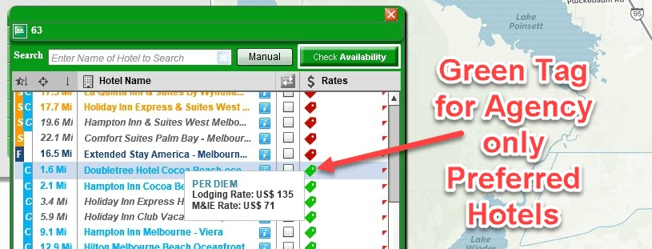

Sorting Hotels
The Hotels in the list view pop-up can be sorted in the following ways:
- By Client Negotiated Hotels then by Agency Preferred Hotels (By “Preferred’s”)
- By Distance to the Destination entered
- By Hotel Name
- By Lowest Nightly Rate
The default sort when the map loads is by Preferred’s and then by Distance as shown in the image below:

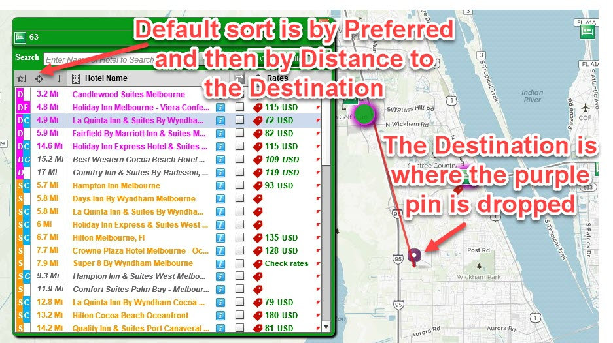
To change the sort order, click on the grey shaded area at the top of any columns. The most used alternate sort is the sort by distance alone. To do that, simply click on the Preferred’s Sort Column (the one of the far left) and the sort only by distance will remain. To return to the sort combining Preferred’s and Distance, click on the Preferred column again.
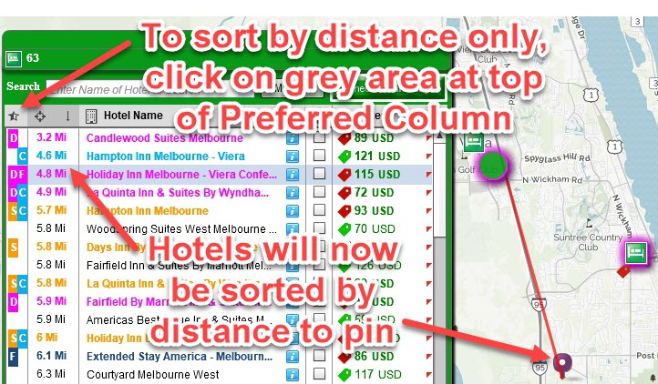

Filtering Hotels in List

To find a specific hotel in the list, you can filter the list of hotels using the following:
- Partial Match of Hotel name
- Hotel Chain
- Street Name

1. Partial Match of Hotel Name
Let’s assume that you are trying to locate a hotel but you only know part of the name. Start typing the word you know (“Viera” in the example below) and the hotels matching your entry will appear:

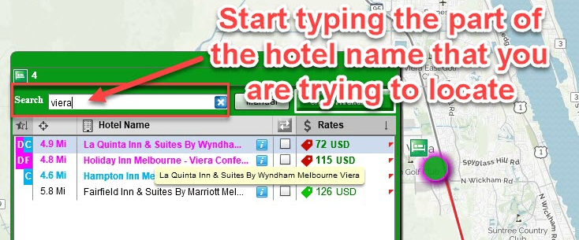

2. Hotel Chain
If you only want to view all the hotels from a specific brand, just enter the GDS Chain / brand code in to the Search box and the list of hotels will filter. Assume you only want to view every Holiday Inn, just type in “*HI” into the box (or “EM” for every Marriott, etc).

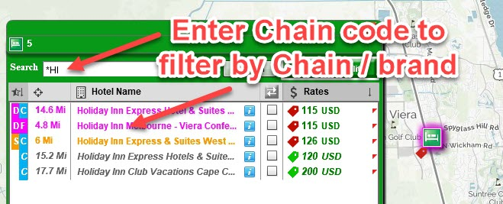

3. Street Name
If you know the street name on which a hotel is located and only want to see the hotels on that street then you can enter the street name (or part of the name) after the “@” sign and only hotels on that street will appear. This filter matches how Sabre would display and return an address search (based on a match with the hotel address) but in practice it is probably more useful to locate potential hotels around the street in question using the Location Search box at the top left of the map.

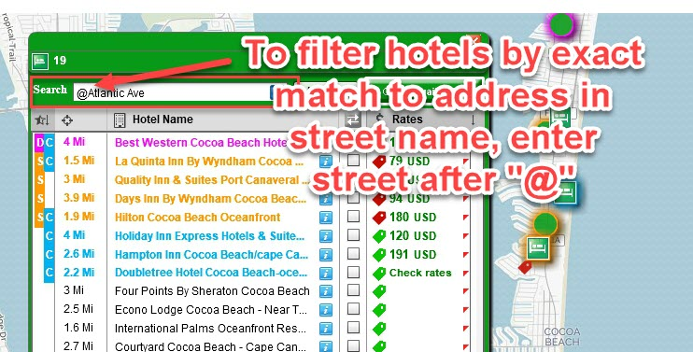

Additional Info on Hotel – Address, Phone Number, Street View, Bird’s Eye View, Reviews

To view more information about a specific hotel, click in the blue “I” icon in the hotel list view as shown below:

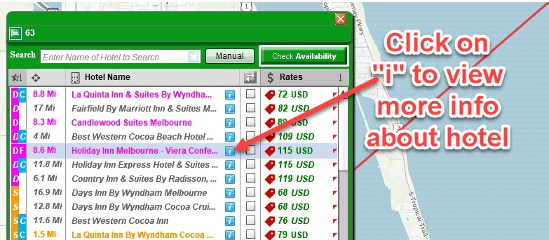

The pop-up will flip around and you can access and view contact summary information about the hotel along with contact info, street view, etc.

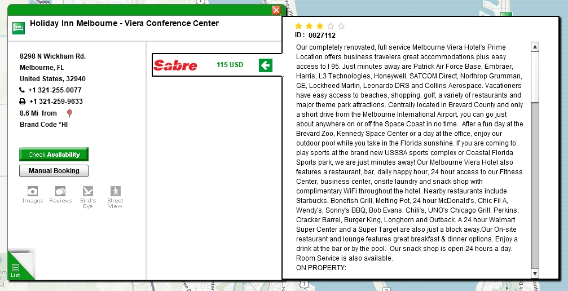

We will now take a look at the Hotel Room Rates Page and describe some of the functionality on this page. You view the room rates after you select a hotel in the List View.

Room Rates Page – with Legend

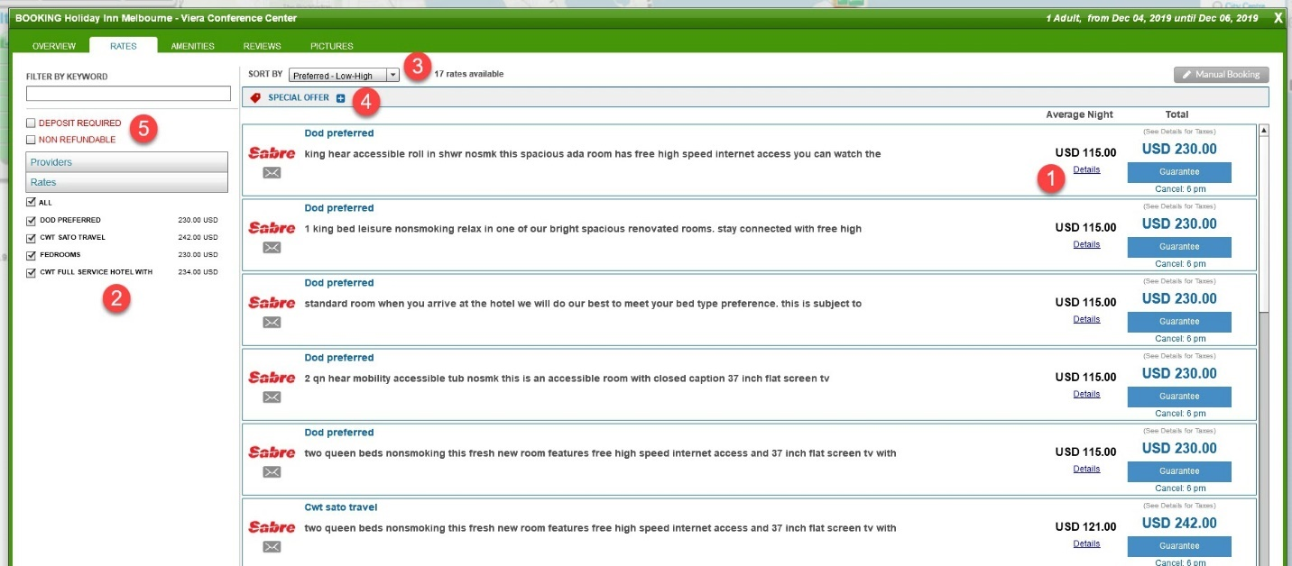

Room Rates – Details

Room Rates Summary by Rate Type

Sort Order for Room Rates

Special Offers Details

Filtering – Keyword Box and Non-Refundable

Room Rates – Details

The rates area to the right of the page shows the Average Nightly Rate excl. Taxes (Base Rate / # Nights). To see the breakdown of the rate you can rollover the Total Rate as shown below:

ROLLOVER ON RATE
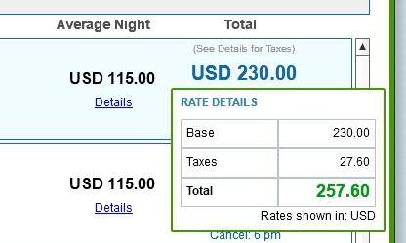

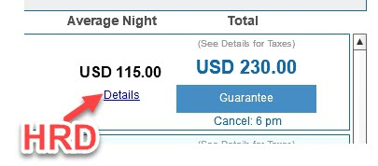

If you click on the “Details” link, it will be the same as the HRD command in Sabre and will shown the detail of the rate. If the Rates Vary over the dates of stay, it will indicate so as shown below. Clicking on the “Details” will open the window to show the nightly rates.

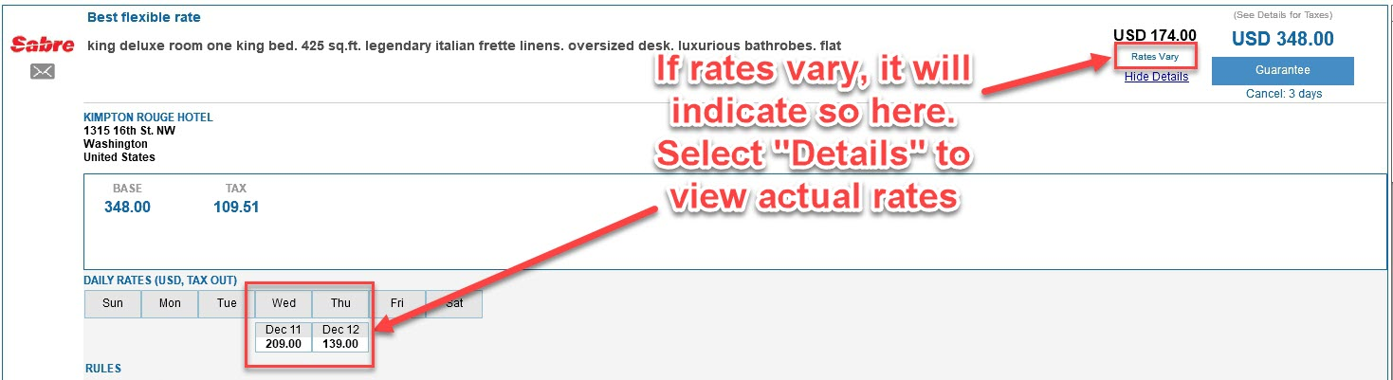

Room Rates Summary by Rate Type

Use the Left Navigation on the Room Rates page to filter and display only the rates that are relevant to your client. The rates displayed are the Total Base Rate for the stay in the currency shown.

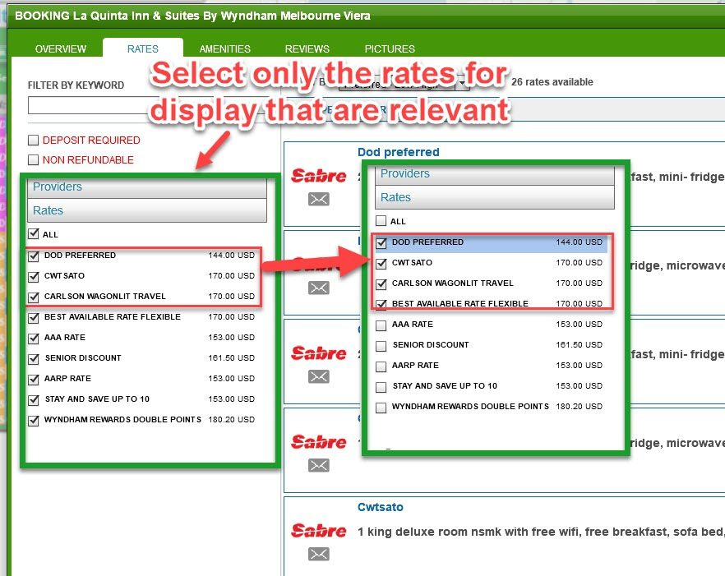

TIP: If the list of rates is not visible as shown above, simply click on the horizontal title bar that says “Rates” and the category will open to display the navigation shown above.
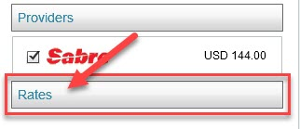

Sort Order for Room Rates

The sort order appearing on the Room Rates Pages can be changed by selecting the drop-down menu at the top.

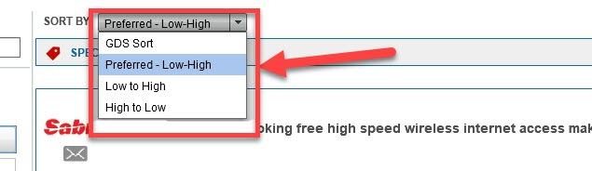

As per the screenshot above, the options are as follows:

GDS Sort
This will display the same sort as in Sabre

Preferred – Low-High
This will display the Room Rates sorted in preference order set by the agency inside the ZoomAndGo Admin. The order is sorted by Rate Code and then by Price (low to high) within the Rate Codes.

Low to High
This will display the Room Rates in order from lowest to highest.

High to Low
This will display the Room Rates in order from highest to lowest.

TIP: The default setting for how these rates are returned when the page first loads is set in the Admin. The order in which the Rates are set in the Admin is actually the same as those displayed in the Rate Code pop-up shown earlier in the map section (Page 19) and this order can be set for the agency, group of agents (PCC) or by Client.

Special Offers Details

Clicking on the “+” button to expand the window will display all the related information about this hotel that has been included as part of the Negotiated or Preferred Rates.

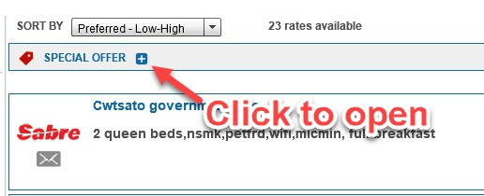

Referring to the image below, this information includes Special Offers / Enhanced Hotel Amenities (e.g. Late Checkout, Free Breakfast, LRA, Free Upgrade, etc.) or information on Negotiated Rates and Commissions. All of this information would have been uploaded to the ZoomAndGo Admin by the Agency and managed and updated as required on an ongoing basis to make this viewable in this area.

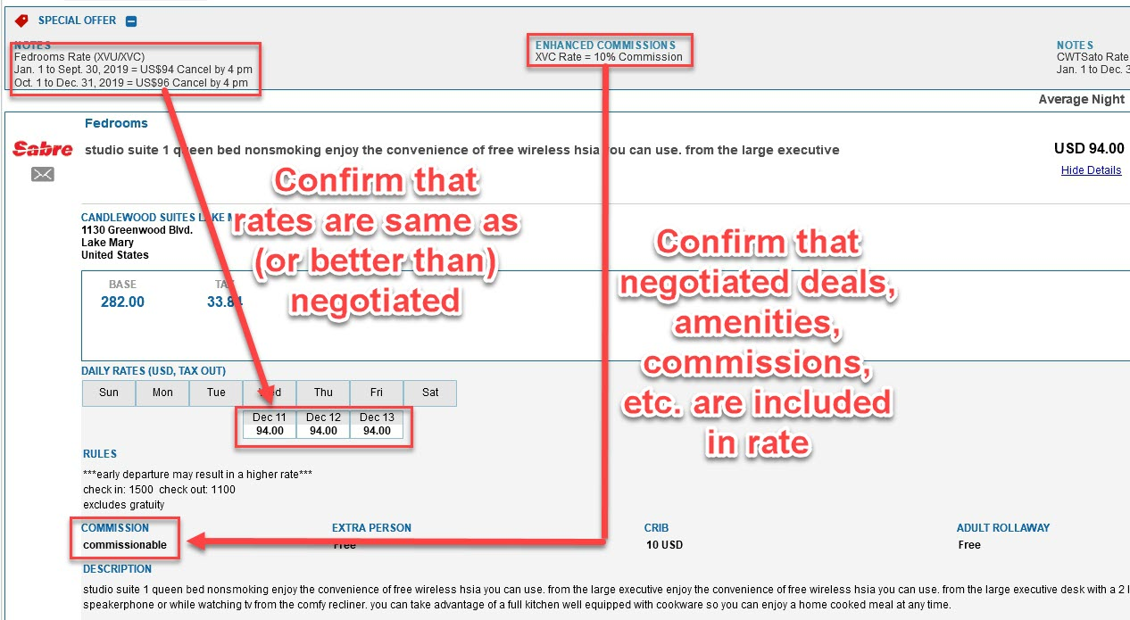

Filtering – Keyword Box and Non-Refundable

Hide Non-Refundable and Deposit Required Rates
On the left of the Room Rates Page, above the navigation for Rates, there is the ability to quickly hide the display of all rates that are either:

- Deposit Required
- Non-Refundable

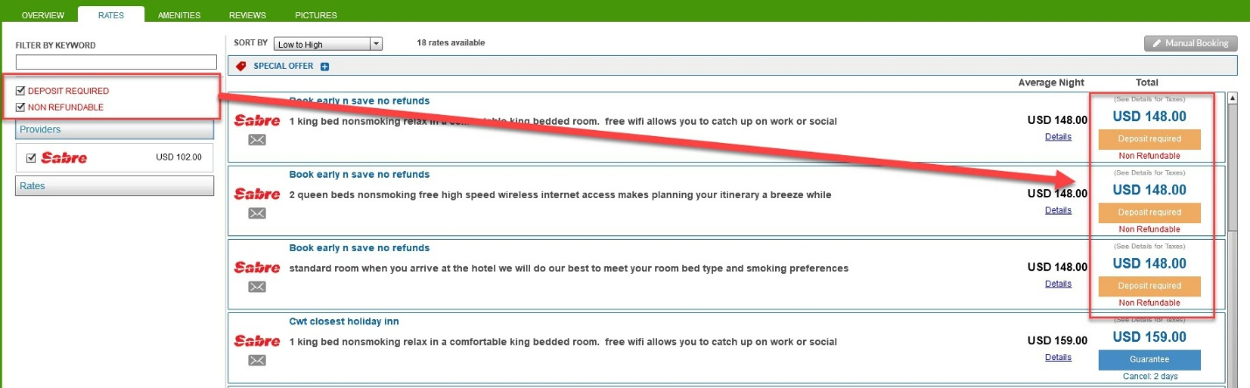

If the check boxes appear as “Checked” that means that somewhere in the list of rates there are Rates that are either Non-Refundable or that require a deposit. By deselecting the checkboxes, it will remove these rate types from the display.

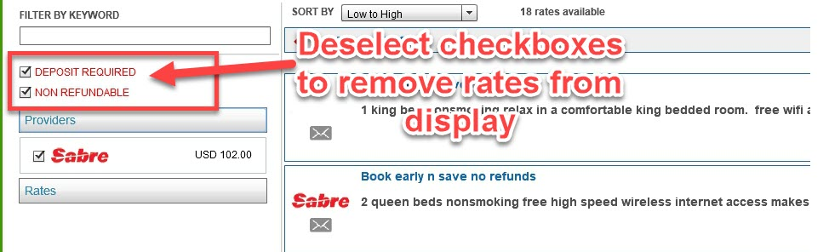

TIP: If an agency would never like to display the Non-Refundable Rates or Deposit Required, these can be set as a default for a Client.

Keyword Box

This box allows you to enter in any word to search within the Room Rates and find rooms matching your search. The search finds matches within the Room Description field and the Room Name.

You can use this box to search for rooms that have Queen beds (type in “Queen”) or rooms that have a view (type in “View”). Note that in looking for rooms for King beds, it might also find the word “smoking” as it is looking for partial word matches as well and that the search may omit some spelling errors or abbreviations entered by the hotel.

